Chapter 8, Solution 9.

s² + 10s + 25 = 0, thus s_{1,2} = 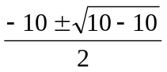 = –5, repeated roots.

i(t) = [(A + Bt)e^{-5t}], i(0) = 10 = A

di/dt = [Be^{-5t}] + [-5(A + Bt)e^{-5t}]

di(0)/dt = 0 = B – 5A = B – 50 or B = 50.

Therefore, i(t) = [(10 + 50t)e^{-5t}] A

